*Looking up and exporting parts*

To look up parts for a vehicle you will want to head to the order or revision tab of a customers ticket. From here you can click on any of the vendors on the bottom of the ticket to open a parts catalog specific to the vehicle you have selected.

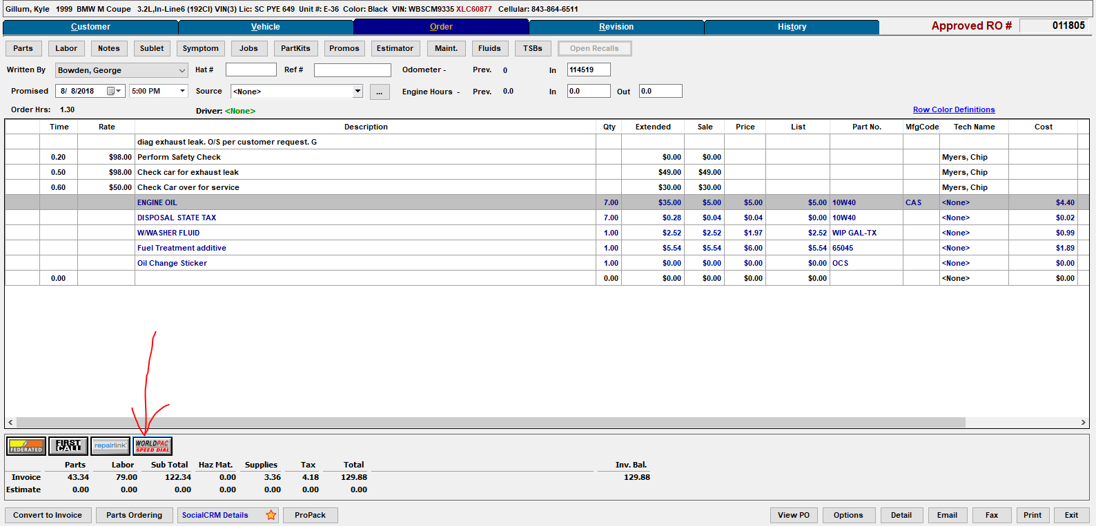

After clicking one of the vendor links it will open up a catalog with all of the vehicles information keyed in, from here you can look up parts needed. For an example we will be adding an oil filter kit

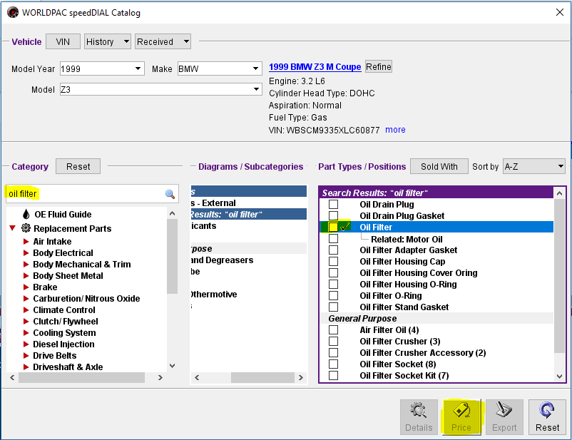

Type in the part you are looking for or navigate through the categories until you find oil filter kit, check the box off and click Price at the bottom, this will show you all of the parts information and allow you to export it back to the RO

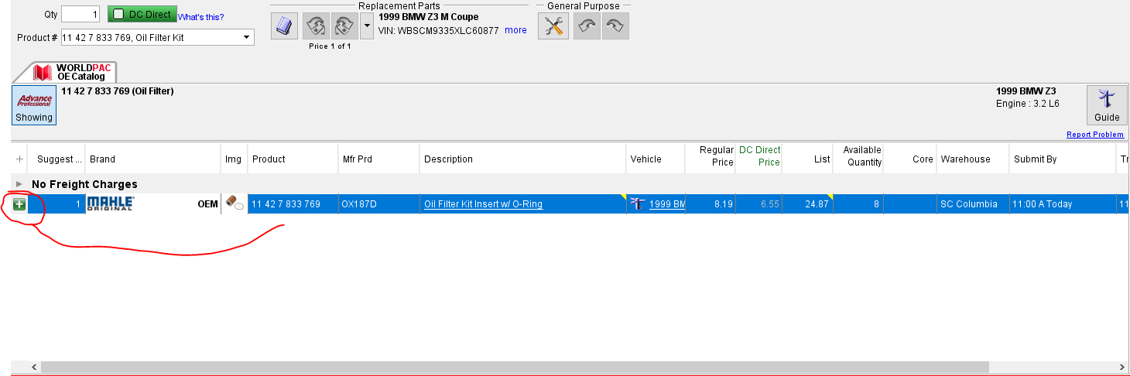

Export the part by clicking the green + symbol and head back into the RO to transfer it to the ticket, after transferring the part you can check inventory to see if the part is in stock

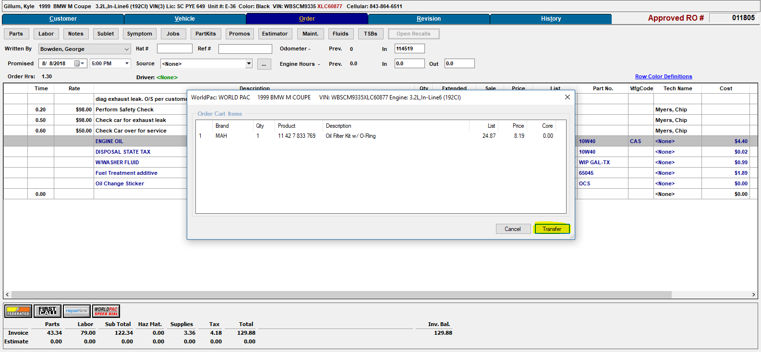

To look up parts that aren’t available through vendor catalogs use RealOEM

*Real OEM*

In any web browser lookup realoem.com from here you will need the VIN # of the vehicle you are trying to find parts for. The VIN # can be found in the vehicle tab of a customers repair order.

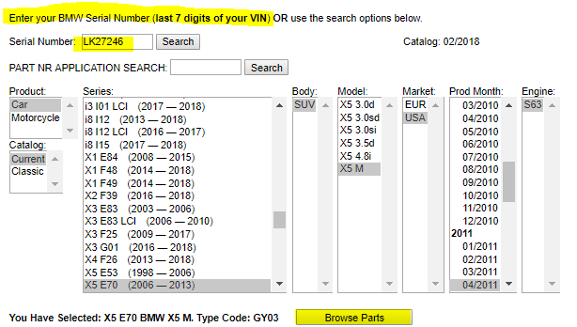

Copy and paste or type in the last 7 digits of the VIN and then browse for parts. You will not be able to transfer items but you can find part numbers and inquire with the dealer for pricing